

**Assessment 2**

**Triggers**

Author: Bertocco Thomas-Killian - #13758322

Lecturer: Bahtee Eng

CP5503 Enterprise Database Systems - Oracle | SP53 | 2019

12 January 2020

Table of Contents

Task 1 3

Sql script 3

Test result 3

Task 2 4

Sql script 4

Test result 4

Task 3 6

Screening table 6

Sql script 6

Task 4 8

Solution 8

Sql script 8

Task 5 9

Sql script 9

Test result 10

Task 6 11

Sql script 11

Test result 12

# Task 1

## Sql script

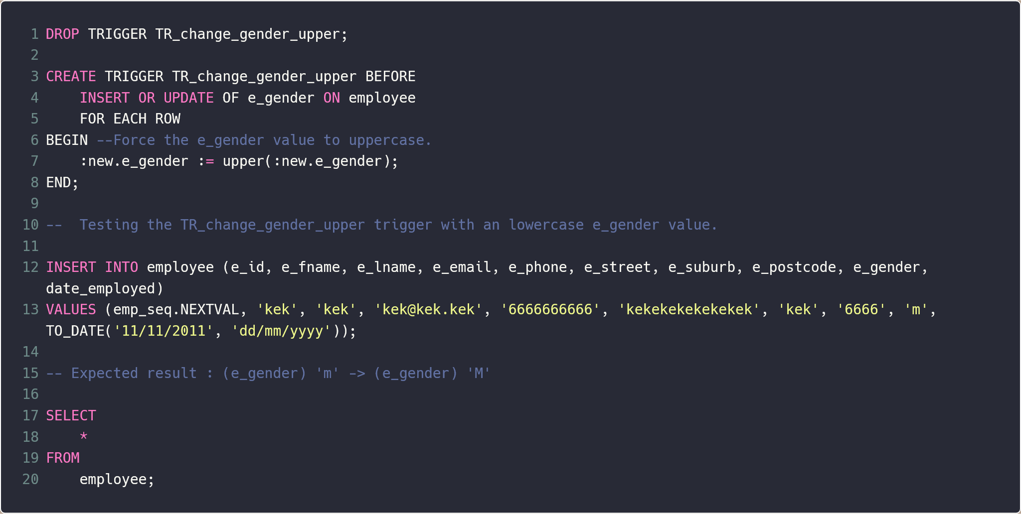

## Test result

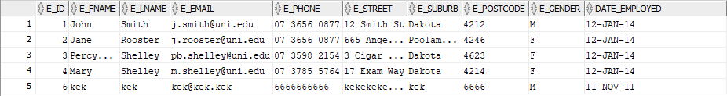

# Task 2

## Sql script

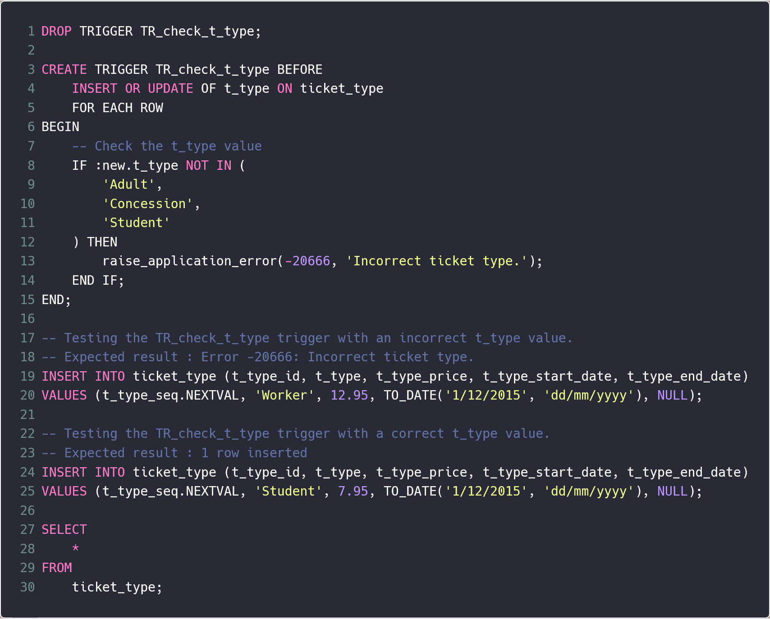

## Test result

First INSERT statement

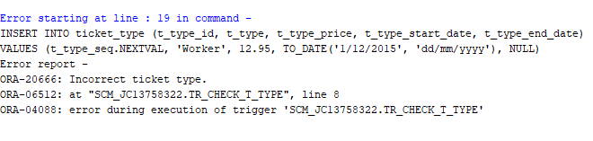

Second INSERT statement

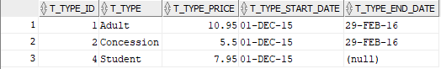

# Task 3

## Screening table

(I changed the order of the original sample table)

|  |  |  |  |  |  |
| --- | --- | --- | --- | --- | --- |
| Screening_id | Plan_id | Theatre_id | Screening_date | Screening_start_hh24 | Screening_start_mm60 |
| 1 | 1 | 4 | 01/02/2016 | 9 | 30 |
| 2 | 1 | 4 | 01/02/2016 | 12 | 0 |
| 3 | 1 | 4 | 01/02/2016 | 14 | 30 |
| 4 | 1 | 4 | 01/02/2016 | 17 | 0 |
| 5 | 2 | 3 | 01/02/2016 | 9 | 30 |
| 6 | 2 | 3 | 01/02/2016 | 12 | 0 |
| 7 | 2 | 3 | 01/02/2016 | 14 | 30 |
| 8 | 2 | 3 | 01/02/2016 | 17 | 0 |
| 9 | 2 | 3 | 01/02/2016 | 19 | 30 |
| 10 | 2 | 4 | 01/02/2016 | 19 | 30 |
| 11 | 3 | 1 | 01/02/2016 | 9 | 30 |
| 12 | 3 | 1 | 01/02/2016 | 12 | 0 |
| 13 | 3 | 1 | 01/02/2016 | 14 | 30 |
| 14 | 3 | 1 | 01/02/2016 | 17 | 0 |
| 15 | 3 | 1 | 01/02/2016 | 19 | 30 |
| 16 | 4 | 2 | 01/02/2016 | 9 | 30 |
| 17 | 4 | 2 | 01/02/2016 | 12 | 0 |
| 18 | 4 | 2 | 01/02/2016 | 14 | 30 |
| 19 | 4 | 2 | 01/02/2016 | 17 | 0 |

## Sql script

(In the code, I added a sequence for the screening id and for the screening plan)

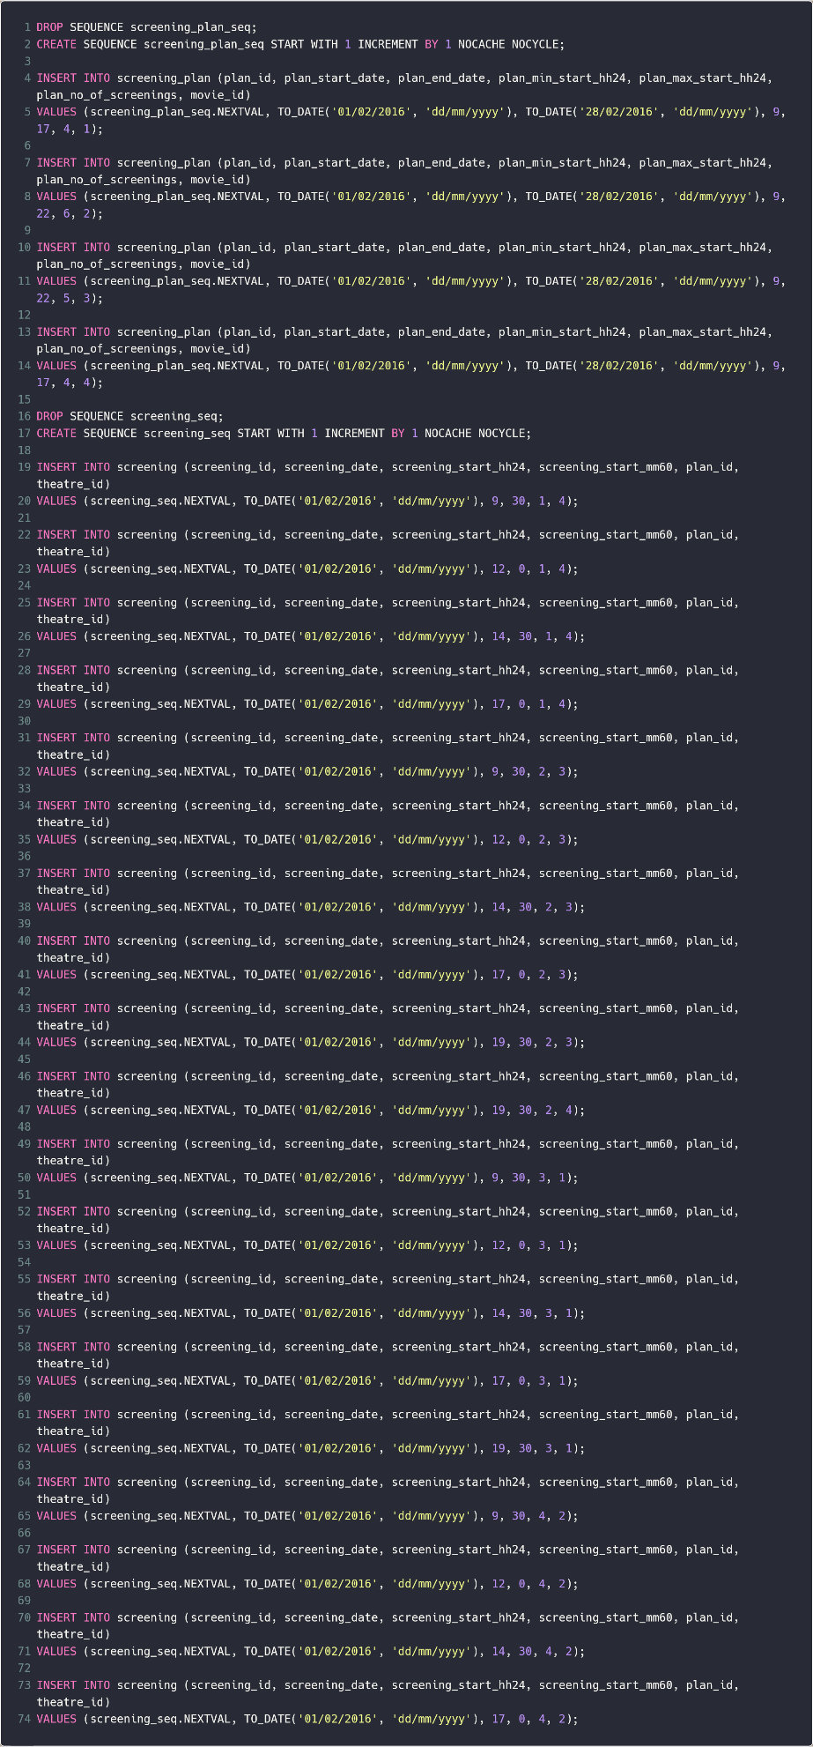

# Task 4

## Solution

My solution is to create a loop in a loop. The first loop is in charge of modifying the day modifier variable. The second loop that is inside the first one, is in charge of creating new rows by copying the date from the 19 original rows from day 1, and by adding the day modifier variable to the date column.

## Sql script

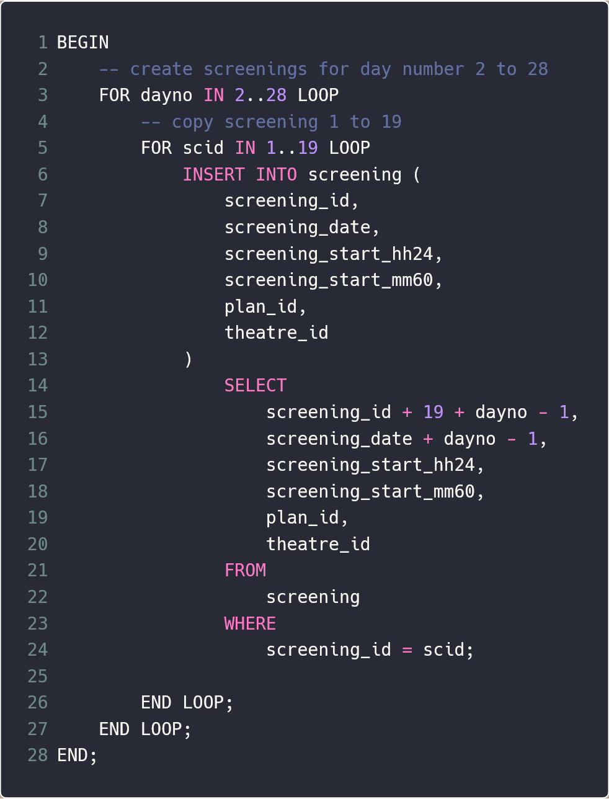

# Task 5

## Sql script

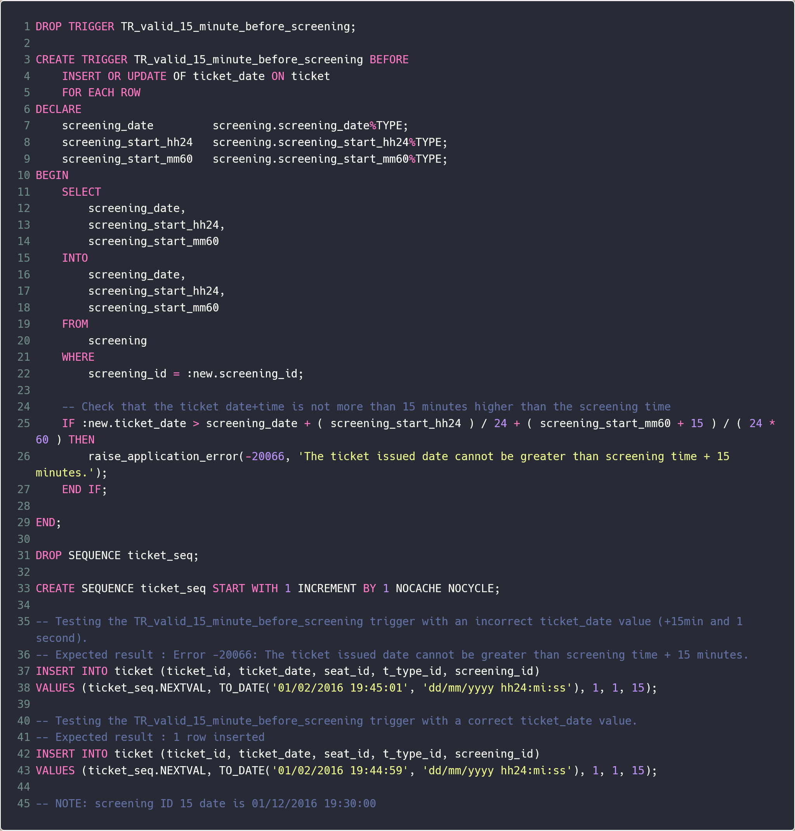

## Test result

First INSERT statement

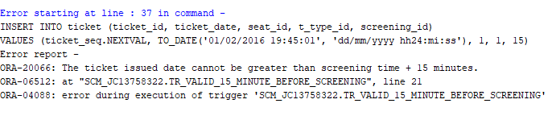

Second INSERT statement



# Task 6

## Sql script

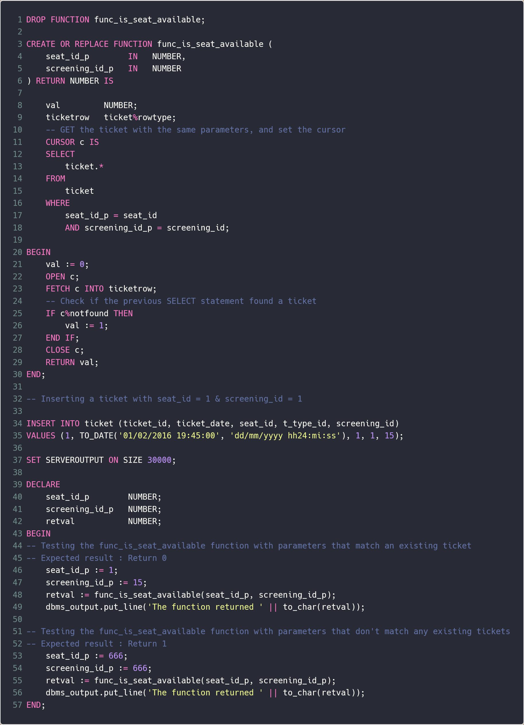

## Test result

Anonymous block result:



Direct call to the function with the first parameters (1,15)



Direct call to the function with the seconds parameters (666,666)

